Assignment 7

Shattering number

The Basics
Before Wednesday 10/22: read this document and make note of any questions you might have.

Wednesday 10/22 and Friday 10/24: will be studio classes devoted to this assignment.

Monday 10/27: present your assignments

Monday 11/3: final version due in class.
The main value that theory adds to computer science is in the analysis of algorithms. The hardest part of theory but potentially most powerful is to understand the *limits* of algorithms. Though P and NP are a well-developed (if incomplete) theory with real-world insights about running time as a resource, the theories underlying the limits of machine learning have not yet been quite as successful, but the theory is still robust and informative.

But before going more abstract, let’s go a little more concrete. In a real-world machine learning setting, a hypothesis space represents all models that share the same parameters, such as a class of neural nets. Machine learning tends to view a learning algorithm as something that adjusts the parameters of a model to minimize the loss function. From a theory perspective, we think of learning as a search problem, where the “same” model with different parameters is a different model; i.e., the parameters define the model.

Now we will go more abstract. For now, we will consider only functions over ℝ²→ℤ₂, and we will assume that the relationship between each x ∈ X and y ∈ Y in the dataset is deterministic (unlike in the previous example where one x value was associated with two different y values).

Think about how one might visualize a training set or a model in this space.

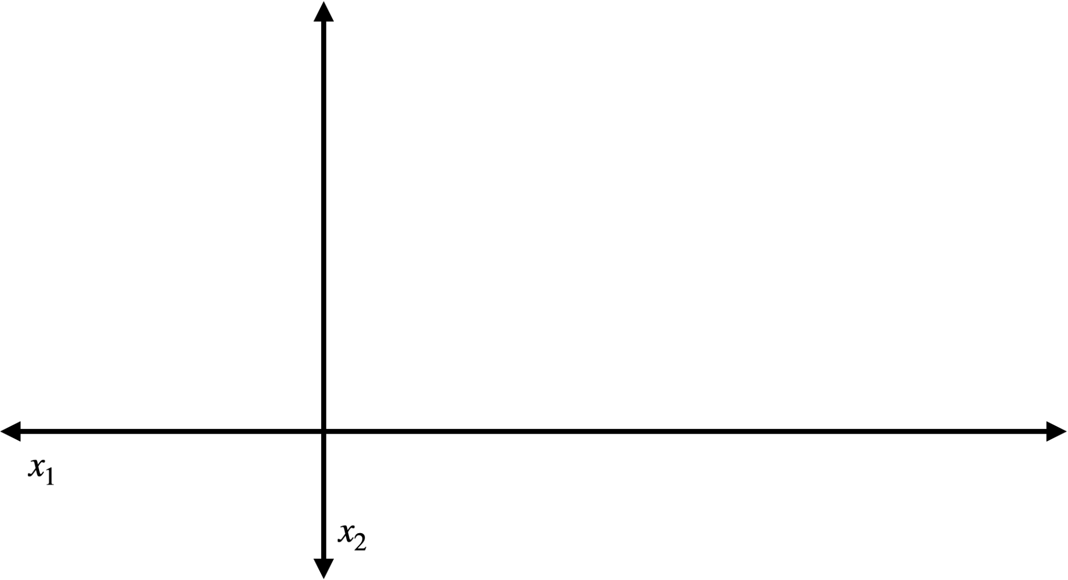
One convenient way is to represent the input as a point in the plane and the output as the shape of the marker used to represent that point.
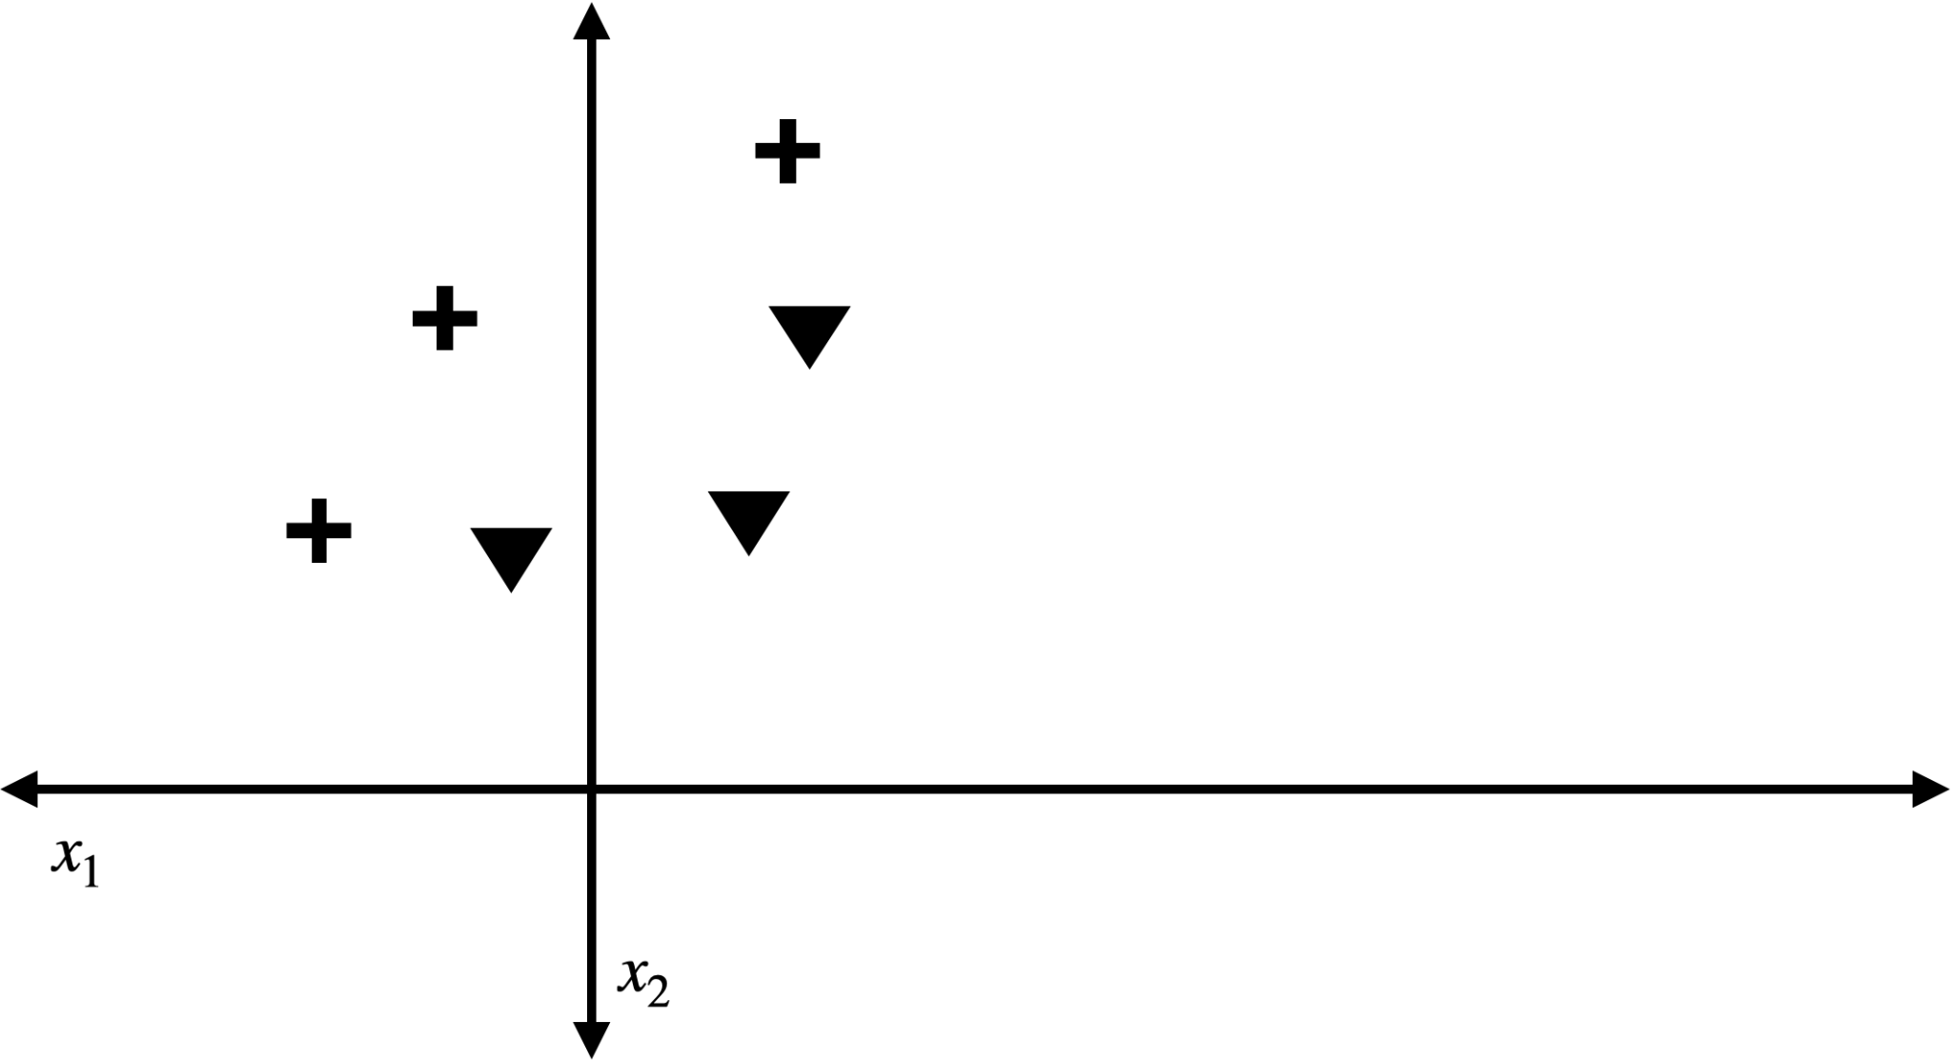
And we can represent any function such as f or a model as two-color (or shade) regions in space, where each color represents a different value.

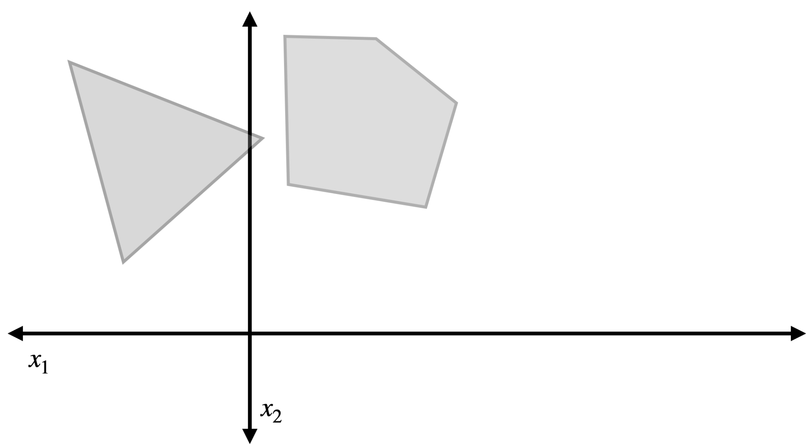

One way to measure (and visualize) loss is how well the model separates data items with different y values.

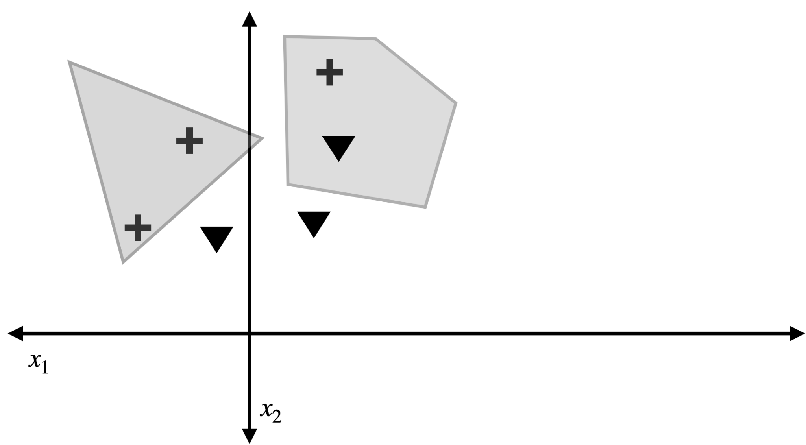

In the example above, for instance, all three plus signs are in gray regions, so they would all be classified the same way. However there is also one triangle in the gray area, while the other two are in the white area. So this model does not perfectly classify the data. However, the model below does.
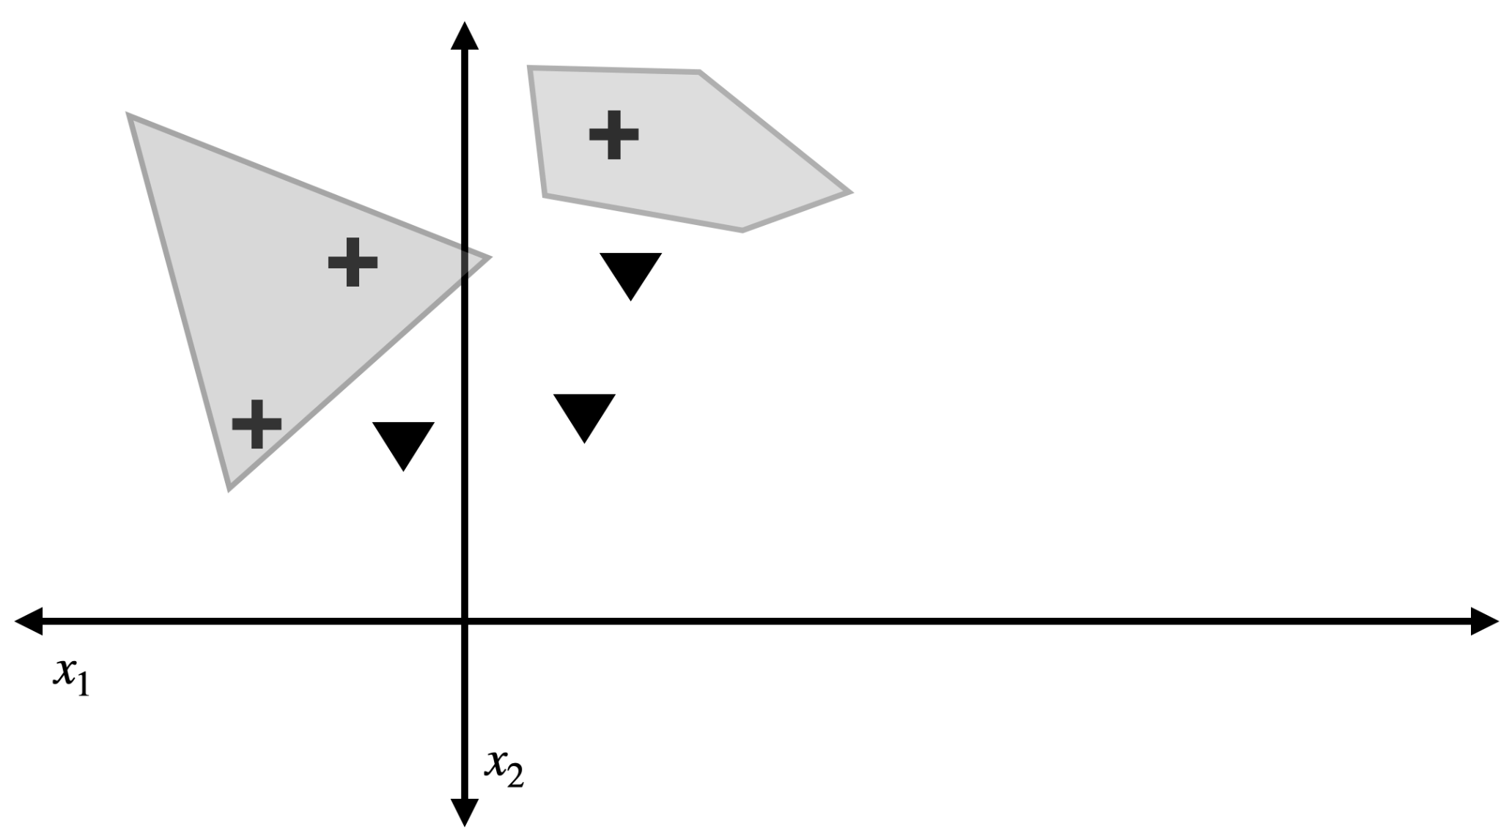
As does this model.
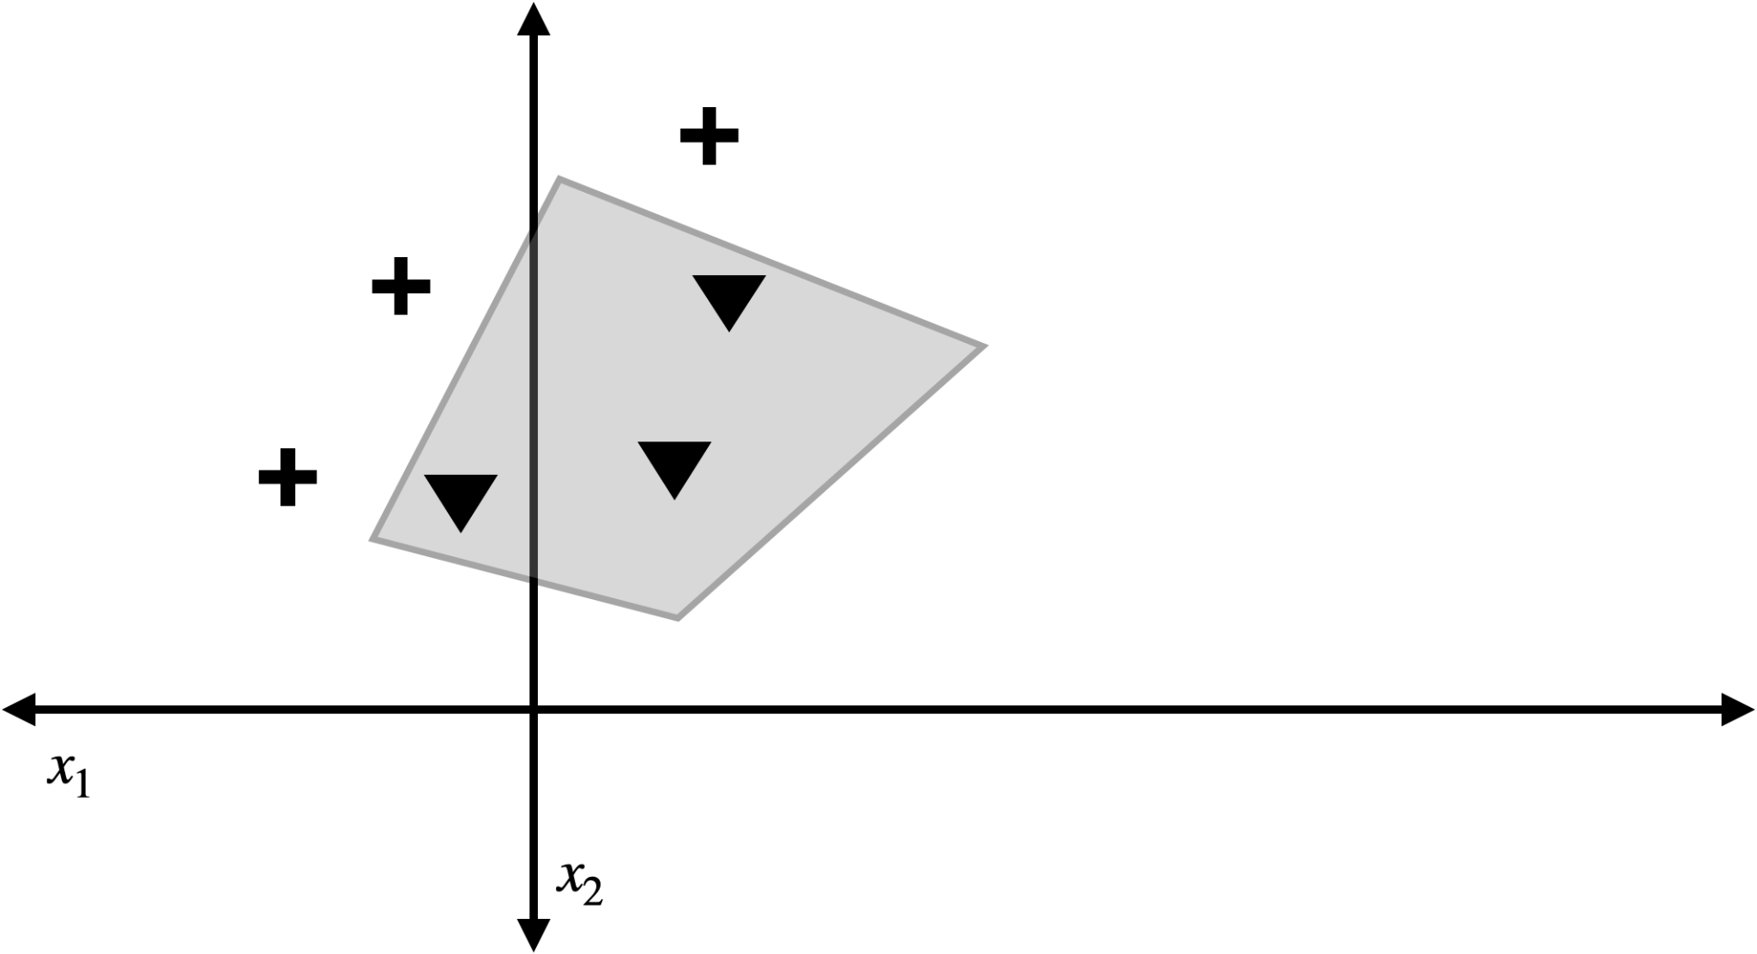

When a model perfectly separates the data, we say that it shatters the dataset.

The theory of VC dimension is not about the limitations of algorithms at all, but of hypotheses, instead, it provides a measure of how expressive a hypothesis space is, or what its capacity for learning is. It says nothing, however about the algorithmic feasibility of *finding a good hypothesis* in the space, so a space with high VC dimension is not necessarily easy to use. However, a space with low VC dimension may not have enough power to faithfully enough represent the data. The goal of this assignment is to teach you what VC dimension is.

The hypothesis space of linear classifiers over ℝ²→ℤ₂ is the set of all functions of the form
sign(ax₁ + bx₂ + c)
Here, the subscript represents the coordinate of a single x value, not the index of a particular x value (which should be clear from context because a model is defined over all points), and a, b, and c are parameters of the model.

Q1. Draw a linear classifier that shatters the dataset below.
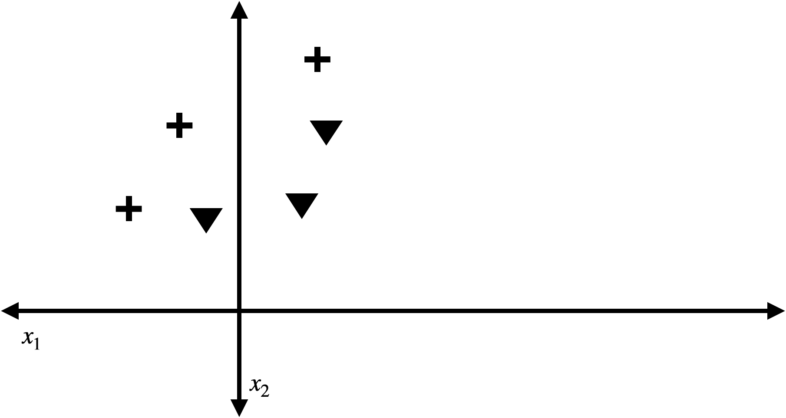

Q2. Draw a linear classifier that does not shatter the dataset..



We extend the concept of shattering from a model to a hypothesis space by saying that a hypothesis space shatters a labeled dataset if there is a model in the hypothesis space that shatters the dataset.

Q3. Which of the following datasets does the hypothesis space of linear classifiers shatter? For each dataset that is shattered, draw a linear classifier that shatters it.
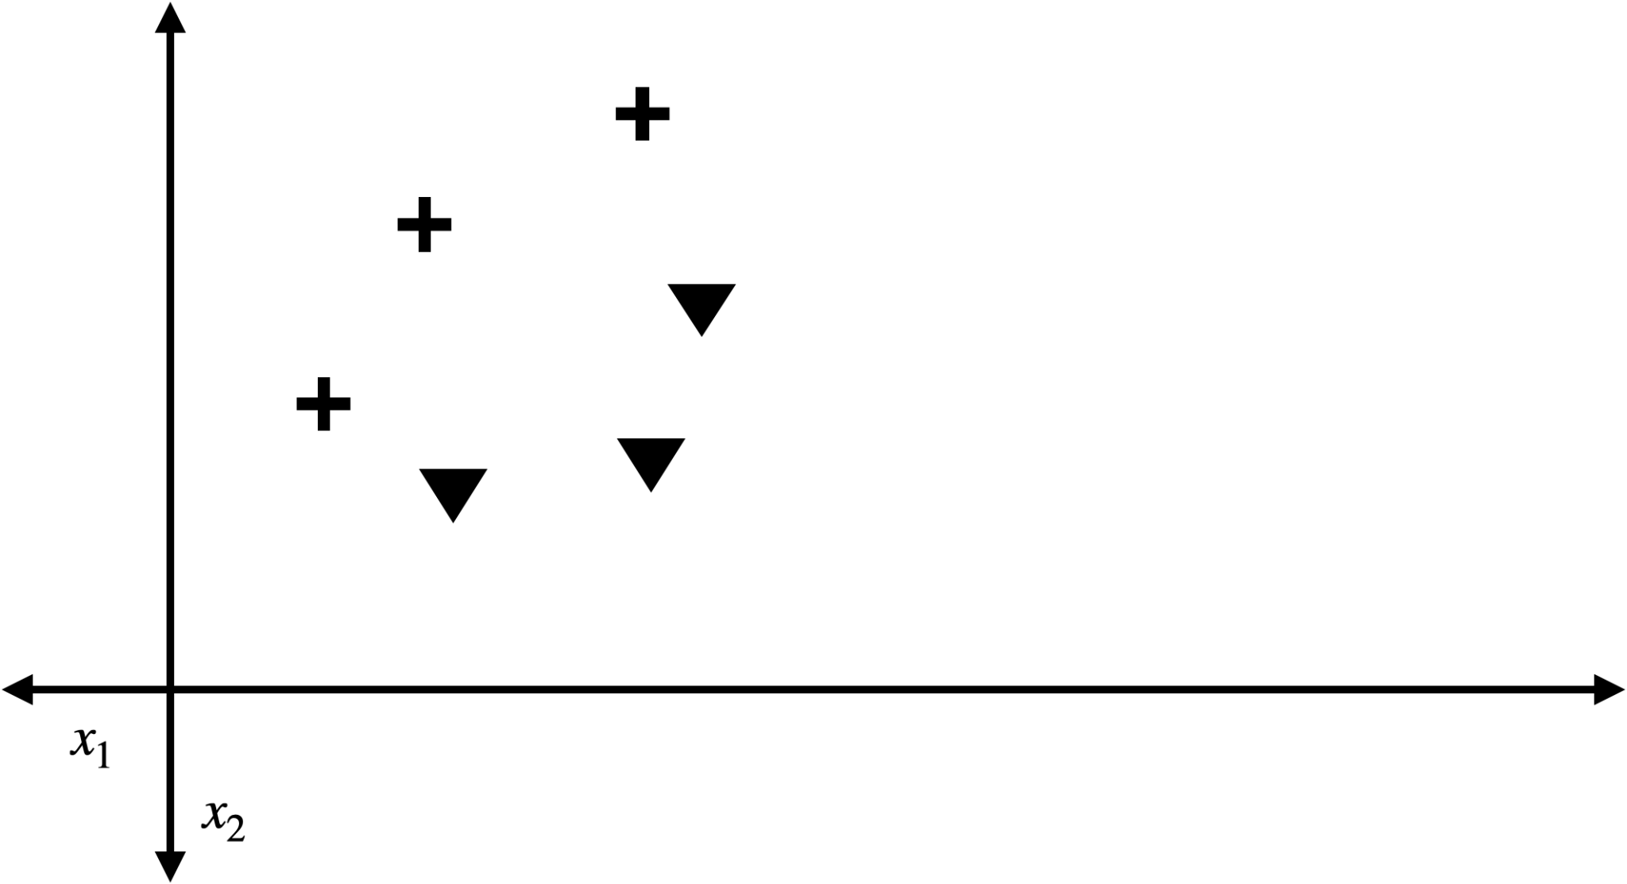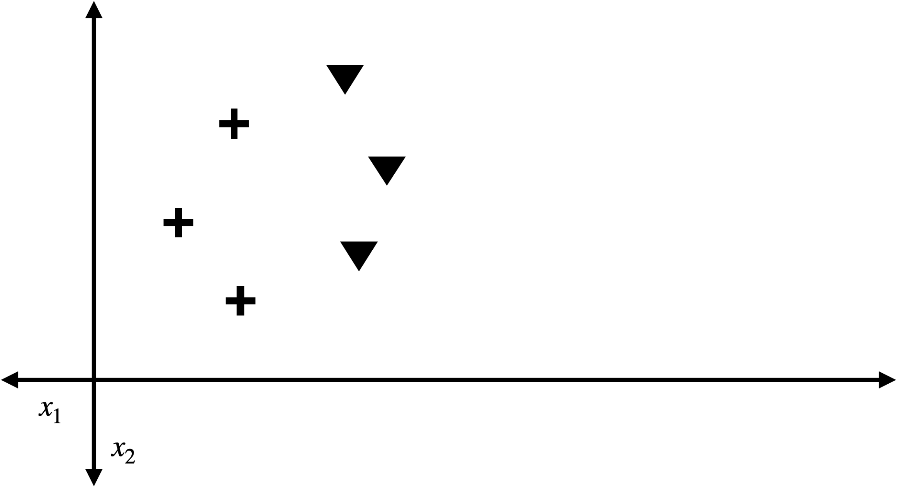
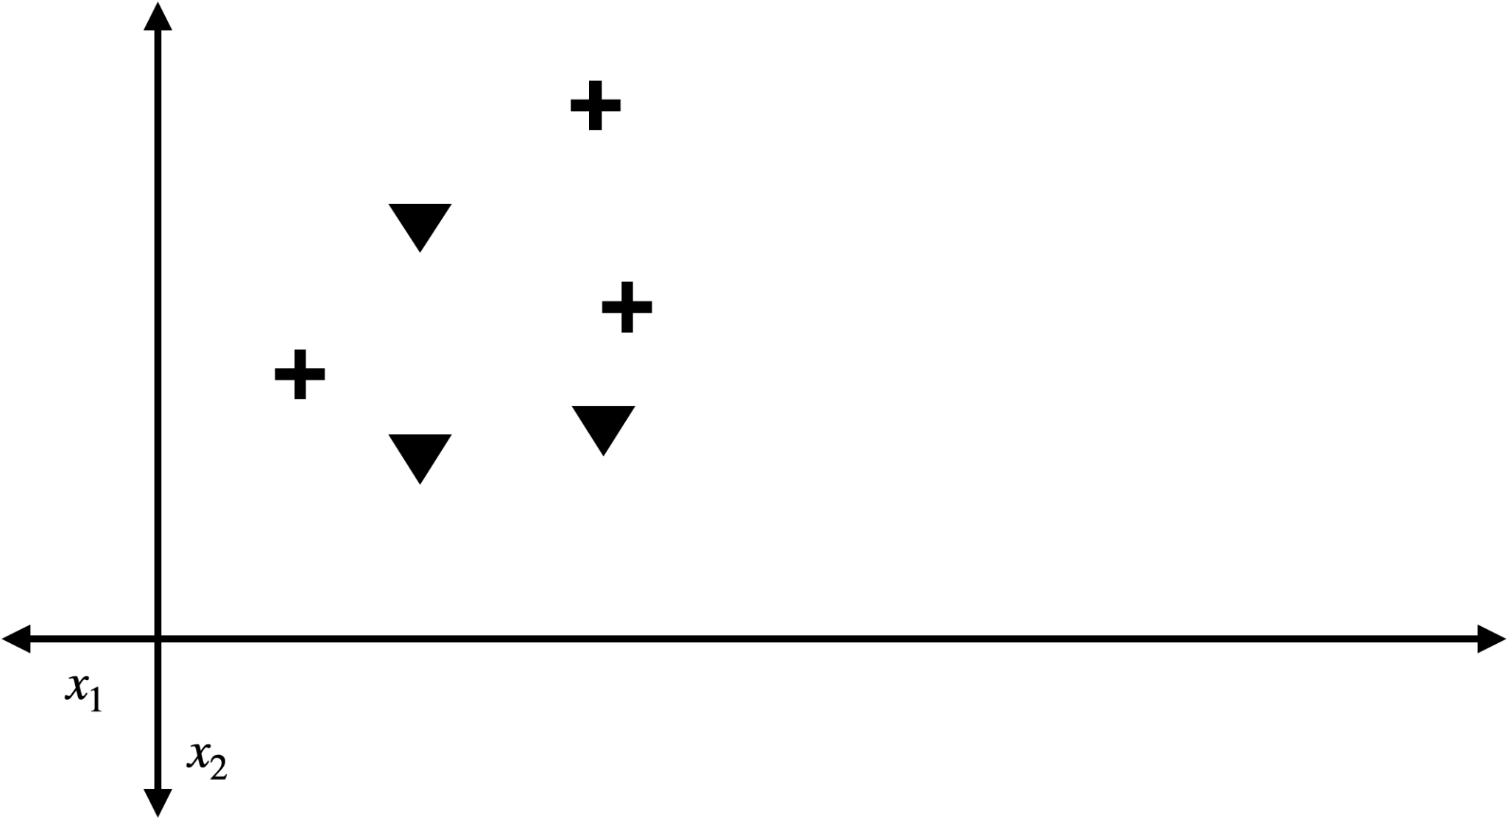

Next we can extend the concept to unlabeled data. Let us represent unlabeled data as circular points.
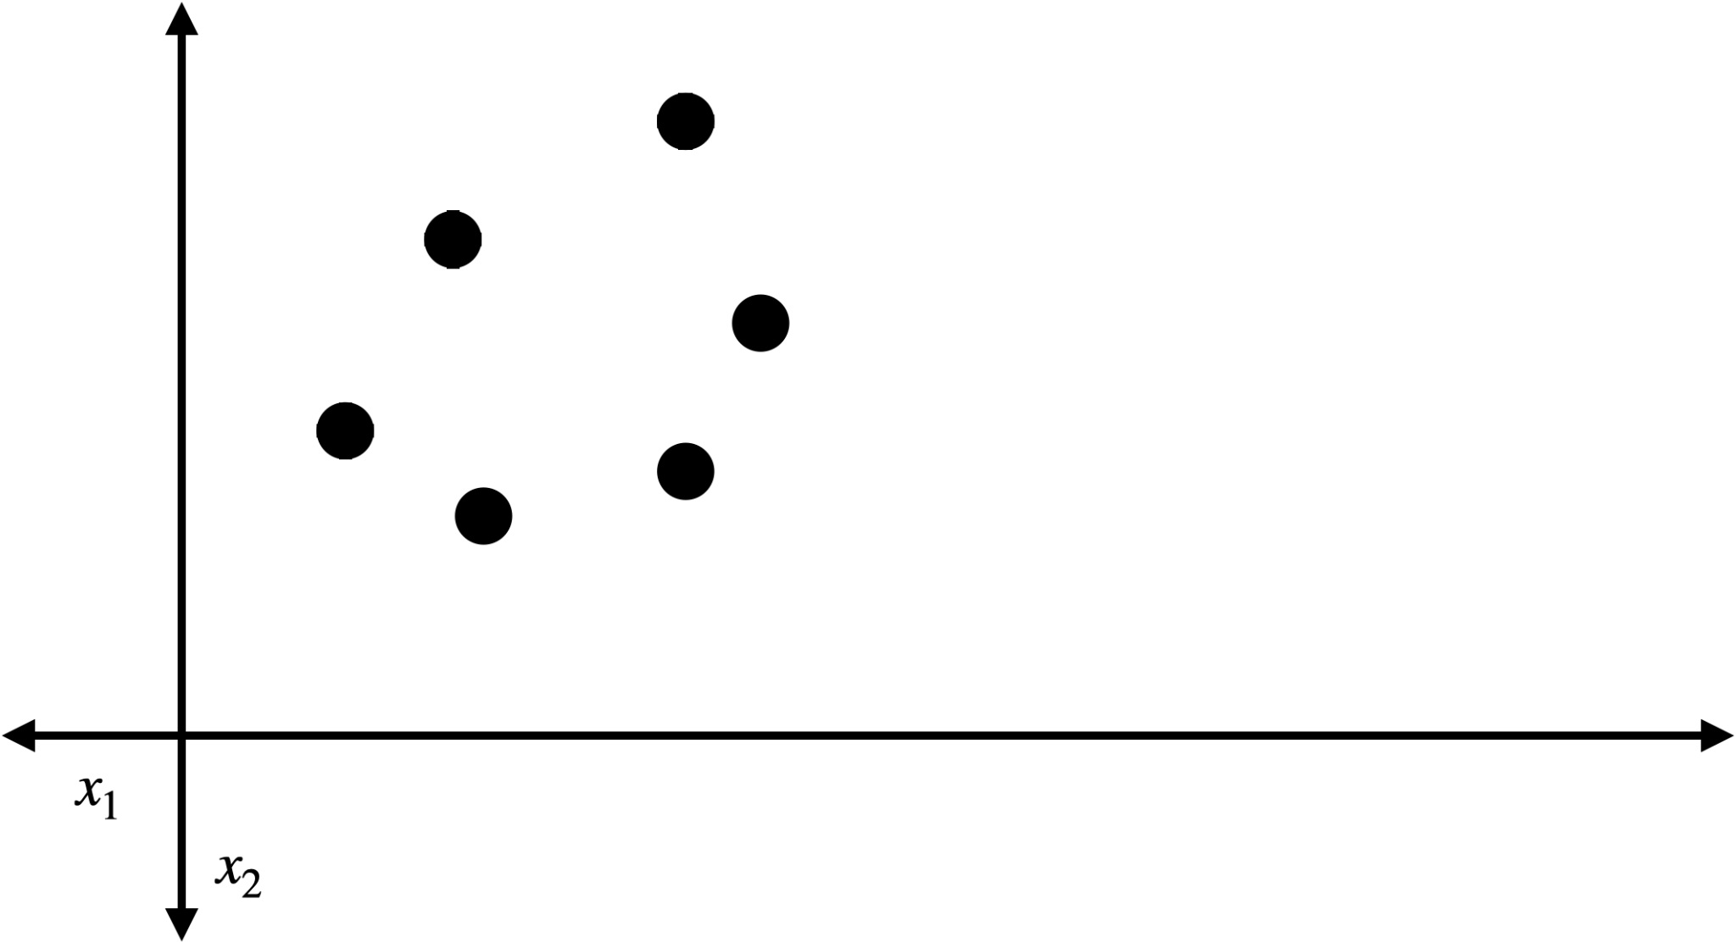

We say that a hypothesis space shatters an unlabeled dataset if for every way to label the dataset the hypothesis space shatters it.

Q4. How many different ways are there to label the dataset above with binary labels?

Finally, for any number n, we say that a hypothesis space shatters n if there exists an unlabeled dataset of size n that the hypothesis space shatters.

Q5 What is the largest number n* that the linear classifiers shatter (hint: it is less than 10)? Note, to show this, you need to show that every number less than or equal to n* are shattered, but that n*+1 is not. You do need to show this, i.e, provide a convincing argument. It doesn’t need to be a formal proof, but it should cover all of the main cases of point arrangements/assignments to points, as necessary.

The rectangular classifiers are any classifier that separates the plane into the interior and exterior of a rectangle. For instance, this is a rectangular classifier.
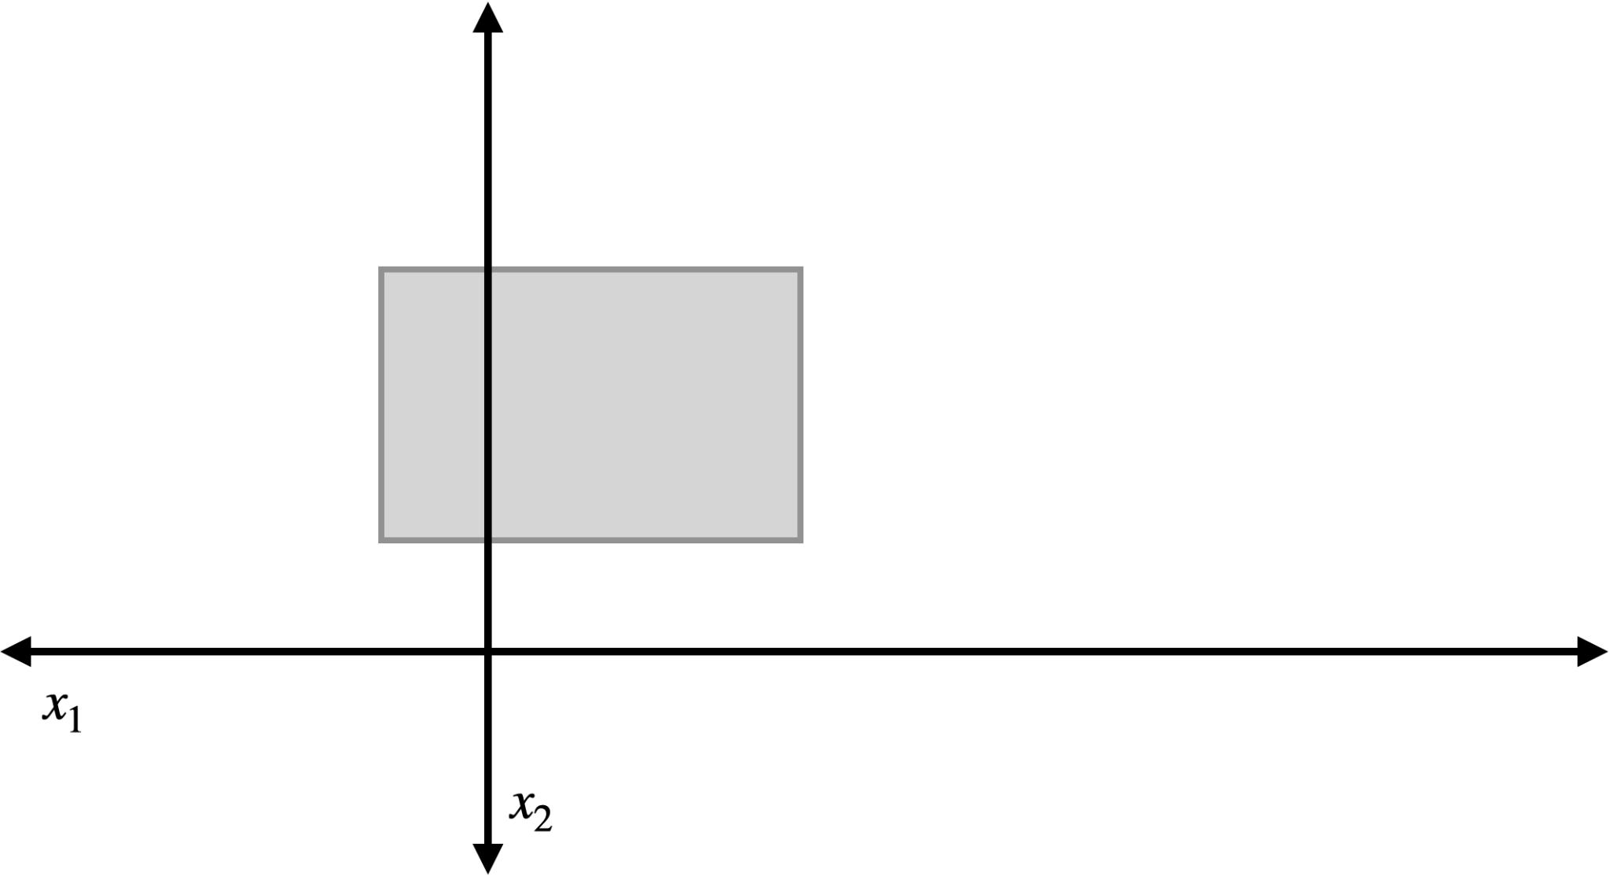

Q6. What is the largest n that the rectangular classifiers shatter? Again, you need to show this with a convincing argument.

